**FLIGHT FARE AUTOMATION SYSTEM**

# A PROJECT REPORT

***Submitted by***

**SAI RUTHWIK (220701237)**

***in partial fulfillment for the course***

## OAI1903 - INTRODUCTION TO ROBOTIC PROCESS AUTOMATION

***for the degree of***

# BACHELOR OF ENGINEERING

***in***

**COMPUTER SCIENCE ENGINEERING**

# RAJALAKSHMI ENGINEERING COLLEGE RAJALAKSHMI NAGAR

**THANDALAM CHENNAI – 602 105**

**NOVEMBER 2024**

# RAJALAKSHMI ENGINEERING COLLEGE CHENNAI - 602105

BONAFIDE CERTIFICATE

Certified that this project report **"Flight Fare Automation System: Streamlining Flight Searches and Price Compilation"** is the Bonafide work of **“SAI RUTHWIK (220701237)”** who carried out the project work for the subject OAI1903 - Introduction to Robotic Process Automation under my supervision.

**MR. DURAIMURUGAN.N, SIGNATURE**

**SUPERVISOR,**

Assistant Professor (SG),

Department of

Computer Science and Engineering,

Rajalakshmi Engineering College,

Rajalakshmi Nagar,

Thandalam,

Chennai – 602105.

Submitted to Project and Viva-Voce Examination for the subject

OAI1903 - Introduction to Robotic Process Automation held on .

**Internal Examiner External Examiner**

# ABSTRACT

This project is designed to automate the monotonous activity of searching for alternative flights and comparing prices between the two defined locations is the aim of this project. Using UiPath Studio, the developed workflow takes advantage of automated technologies at the most sophisticated levels to retrieve information on flight parameters, such as scheduled departure and arrival, airline, number of stops, and price, from airline and travel agency websites. There is a reduction in data search efforts, time, resources and inaccuracy as searches are no longer performed manually.

It is then proceeded to allow the users to enter places and dates of their planned departure and arrival. In this manner, the system goes from the top to the bottom of the websites of airlines or travel suppliers and retrieves data about all flights that are offered. The data which has been collected is presented in a particular manner and put in an Excel file for ease of interpretation, comparison, and dissemination.

In order to make sure the results are presentable without extra work, the workflow takes advantage of UiPath capabilities and integration with Excel activities. The scope of the process is also very large and can be modified by users for new routes and time periods. The built-in features such as dynamic selectors and error handling make it much stronger and more reliable in working with different sites.

# ACKNOWLEDGEMENT

We would like to express our sincere gratitude to everyone who has supported and guided us throughout the course of this project. First, we extend our heartfelt thanks to our Chairman, **Mr. S. Meganathan, B.E., F.I.E.**, our Vice Chairman, **Mr. Abhay Shankar Meganathan, B.E., M.S.,** and our Chairperson, **Dr. (Mrs.) Thangam Meganathan, Ph.D.,** for providing us with the resources and facilities required to complete this project at Rajalakshmi Engineering College.

We are immensely grateful to our Principal, **Dr. S.N. Murugesan, M.E., Ph.D.,** for his support and encouragement throughout our academic journey. My Special thanks go to

**Dr. P. Kumar, M.E., Ph.D.,** Professor and Head of the Department of Computer Science and Design, for her valuable guidance and continuous motivation during this project.

We owe our deepest appreciation to our internal guides, **Dr. N. Durai Murugan**,

Assistant Professor (SG) Computer Science and Engineering Department, for their expertise, feedback, and unwavering support throughout the various phases of this work.

We would also like to thank him towards his Project Coordination, for his constructive suggestions and insights during the review sessions, which greatly contributed to the successful completion of this project.

Finally, we extend our appreciation to our peers, friends, and family for their encouragement and understanding, which played a significant role in our progress.

**-SAI RUTHWIK (220701237)**

# TABLE OF CONTENTS

**CHAPTER NO. TITLE PAGE NO.**

**ABSTRACT**

**LIST OF FIGURES**

**LIST OF ABBREVIATIONS**

1. **INTRODUCTION**

**iii vi vii 1**

* 1. INTRODUCTION 1
  2. OBJECTIVE 3
  3. EXISTING SYSTEM 3
  4. PROPOSED SYSTEM 4

1. LITERATURE REVIEW 5
2. SYSTEM DESIGN 9
   1. SYSTEM FLOW DIAGRAM 9
   2. ARCHITECTURE DIAGRAM 10
   3. SEQUENCE DIAGRAM 11
3. PROJECT DESCRIPTION 12
   1. MODULES 12
      1. INPUT HANDLING AND 12

INITIALIZATION

* + 1. CONTENT ANALYSIS 12
    2. RESULT MANAGEMENT 13
    3. COMPLETION AND REPORTING 13

1. OUTPUT SCREENSHOTS 14
2. CONCLUSION 18

APPENDIX 19

REFERENCES 25

# LIST OF FIGURES

|  |  |  |
| --- | --- | --- |
| **Figure No.** | **Figure Name** | **Page No.** |
| 3.1 | System Flow Diagram | 9 |
| 3.2 | Architecture Diagram | 10 |
| 3.3 | Sequence Diagram | 11 |
| 5.1 | Input Dialog | 14 |
| 5.2 | Excel Creation | 14 |
| 5.3 | AI Content Detection | 15 |
| 5.4 | Plagiarism Detection | 16 |
| 5.5 | Excel Report | 17 |

**LIST OF ABBREVIATIONS**

|  |  |
| --- | --- |
| **ABBREVIATION** | **ACCRONYM** |
| RPA | Robotic Process Automation |
| AI | Artificial Intelligence |
| API | Application Programming  Interface |
| CV | Computer Vision |
| OCR | Optical Character Recognition |

# CHAPTER 1 INTRODUCTION

## INTRODUCTION

This workflow serves as an efficient solution for addressing common challenges in data processing, application interaction, and reporting. By eliminating manual intervention, it not only reduces the effort required to perform routine operations but also ensures higher accuracy and consistency in execution.

At the core of this workflow lies its ability to handle dynamic data. It manages inputs and outputs in a structured and systematic way, supporting diverse data formats and scenarios. This flexibility makes it suitable for applications ranging from data extraction to integration with other digital tools. Moreover, its design ensures seamless orchestration of tasks, connecting individual actions logically to create an efficient and coherent automation process.

A significant feature of the workflow is its integration with Excel and workbook-related functionalities. Leveraging UiPath’s powerful Excel activities, the automation manages spreadsheets effectively, allowing for advanced data manipulation and reporting. This capability makes it particularly useful for business scenarios where data accuracy and organization are critical.

Another key aspect is the scalability and customization of the workflow. Built to handle variable scenarios, it can be tailored to specific use cases, making it adaptable to both simple and complex processes. Whether automating basic data entry or managing sophisticated workflows across multiple systems, the workflow demonstrates its versatility in various environments.

Overall, this UiPath automation workflow exemplifies the potential of Robotic Process Automation (RPA) to streamline operations, improve accuracy, and enhance overall efficiency. By focusing on optimizing routine tasks, it empowers users to redirect their attention to higher-value activities, contributing to improved performance and productivity in a wide range of applications.

## 

## OBJECTIVE

The objective of this bot is to automate repetitive and structured tasks, streamline data processing, and enhance productivity by leveraging UiPath's capabilities. It aims to ensure accuracy, consistency, and efficiency in operations such as data extraction, workbook management, and reporting, reducing manual effort and optimizing workflows for diverse applications.

## PROPOSED SYSTEM

The proposed solution is an automation workflow developed using UiPath to streamline and automate repetitive tasks such as data extraction, processing, and report generation. The workflow is designed to handle dynamic inputs and outputs, ensuring compatibility with various data formats. By automating these tasks, it eliminates the need for manual intervention, reducing errors and saving time.

The solution integrates key functionalities, such as Excel workbook manipulation and seamless interaction with other applications, ensuring a smooth and efficient process. It is scalable and customizable, allowing it to be tailored to meet specific business needs, from basic data handling to more complex workflows. This solution ultimately enhances productivity by freeing up resources for higher-value activities while ensuring consistency and accuracy in operations.

**CHAPTER 2**

**LITERATURE REVIEW**.

**2.1 Survey on Robotic Process Automation (RPA) in Software Development:**

Robotic Process Automation (RPA) is increasingly recognized as a valuable asset in software development, automating repetitive tasks to boost efficiency and reduce manual effort. For example, RPA has been successfully implemented in automating build processes, code reviews, and deployment pipelines, significantly easing the workload of developers. However, challenges persist, particularly in automating complex decision making and tasks that require human creativity. The literature review of research papers related to RPA in Software Development is listed below:

A study discusses how the integration of RPA in software development can lead to substantial time savings and reduced error rates. The research highlights the automation of repetitive coding tasks and its impact on improving developer productivity.

Another research paper from the International Journal of Computer Applications (IJCA) explores the application of RPA in continuous integration and continuous deployment (CI/CD) pipelines. The paper concludes that RPA can streamline these processes, resulting in faster and more reliable software releases.

**2.2** **Survey on Full-Stack Development Automation:**

Automating full-stack development tasks is an area of growing interest, particularly in the context of enhancing productivity and maintaining consistency. Existing tools and frameworks offer varying degrees of automation, from scaffolding project structures to 12 managing dependencies. The literature review of research papers related to Full-Stack Development Automation is listed below:

Research investigates the use of automation tools for setting up full-stack development environments. The study highlights the benefits of automating project initialization, including reduced setup time and improved consistency across development teams.

A paper from the Journal of Software Engineering examines the effectiveness of automation frameworks in managing full-stack development workflows. The research concludes that automation can significantly reduce the manual effort involved in environment setup and configuration.

**2.3 Survey on Efficiency in Software Project Initialization:** Efficiency in software project initialization is critical to kick-starting development activities smoothly. Automation plays a key role in achieving this efficiency by minimizing the time and effort required for initial setup. The literature review of research papers related to efficiency in software project initialization is listed below:

An article discusses various automation techniques for initializing software projects, focusing on the integration of RPA tools to streamline initial setup processes. The study emphasizes the time-saving benefits and reduction in human errors.

A survey by the Institute of Electrical and Electronics Engineers (IEEE) provides insights into different approaches to automate project setup, including the use of scripting and RPA. The paper underscores the potential of these methods in enhancing setup efficiency and consistency.

**2.4 Summary of the Intersection of RPA, Full-Stack Automation, and Project Initialization Efficiency:**

The "Full-Stack Project Setup Automation Bot" integrates these areas, leveraging RPA to automate the initialization of full-stack projects involving React and Express. The project incorporates advanced automation techniques to execute necessary commands and configurations within VSCode. Additionally, it addresses the challenges of maintaining consistency and reducing setup time, positioning the bot as a pivotal tool in enhancing development workflows. The project’s innovative approach aligns with current trends in software development, presenting a timely solution to the complexities of project setup. The integration of RPA with full-stack development automation showcases the bot's significance in contributing to more efficient and reliable software development processes.

# CHAPTER 3 SYSTEM DESIGN

## SYSTEM FLOW DIAGRAM

A flowchart is a type of diagram that represents an algorithm, workflow or process. The flowchart shows the steps as boxes of various kinds, and their order by connecting the boxes with arrows. This diagrammatic representation illustrates a solution model to a given problem. The system flow diagram for this project is in Fig. 3.1.

Fig 3.1 System 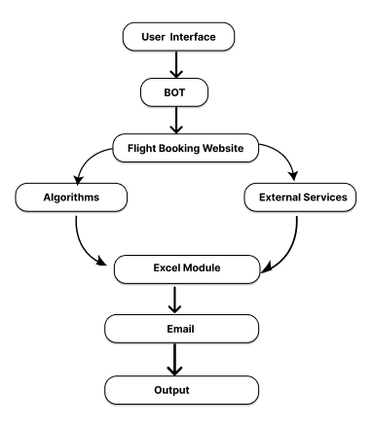 Flow Diagram

## ARCHITECTURE DIAGRAM

An architecture diagram is a graphical representation of a set of concepts, that are part of an architecture, including their principles, elements and components. The architecture diagram for this project is in Fig. 3.2.

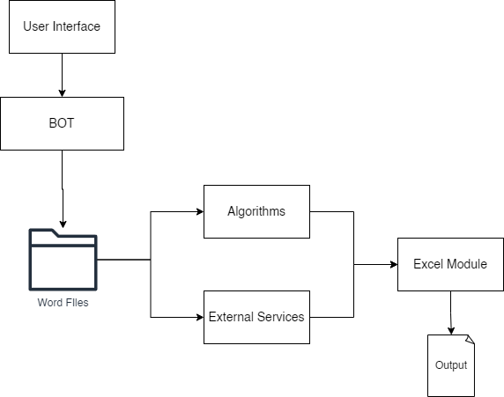

Fig 3.2 Architecture Diagram

## SEQUENCE DIAGRAM

A sequence diagram is a type of interaction diagram because it describe and s how in what order a group of objects works together. The sequence diagram for this project is in Fig. 3.3.

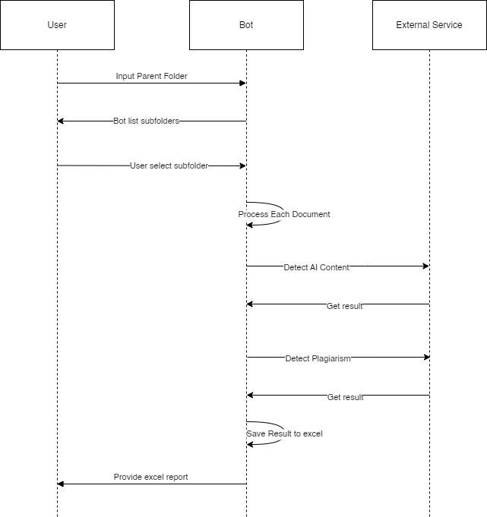

Fig 3.3 Sequence Diagram

# CHAPTER 4 PROJECT DESCRIPTION

The project involves the development of an automation workflow using UiPath to streamline and optimize repetitive tasks, such as data extraction, processing, and report generation. The workflow aims to eliminate manual intervention, increase accuracy, and reduce the time required to complete routine tasks in business processes. By automating the entire process, the project enhances operational efficiency and allows users to focus on more complex and value-driven tasks.

**4.2 MODULES:**

**Key Features:**

1. **User Interface:**

* Provides an interface for users to initiate the process and manage inputs.
* Simple and intuitive interaction with the bot.

1. **Automation Bot:**

* Automates the workflow, eliminating the need for manual intervention.
* Accesses Word files and orchestrates the subsequent data processing steps.

1. **Word Files Access:**

* Reads and extracts data from Word files in the selected directory.
* Ensures compatibility with common Word document formats.

1. **Algorithms:**

* Processes the extracted data using custom algorithms to evaluate or transform the content.
* Optimized for accurate and efficient data processing.

1. **External Services:**

* Utilizes third-party APIs or tools to enhance data processing, such 19 as validation, enrichment, or analysis.
* Ensures reliable integration with external platforms.

1. **Excel Module:**

* Combines processed results into a structured Excel sheet.
* Prepares the final output in a format suitable for analysis or reporting.

1. **Output Generation:**

* Produces the final output file for the user.
* Ensures accurate, readable, and actionable results.

# CHAPTER 5 OUTPUT SCREENSHOTS

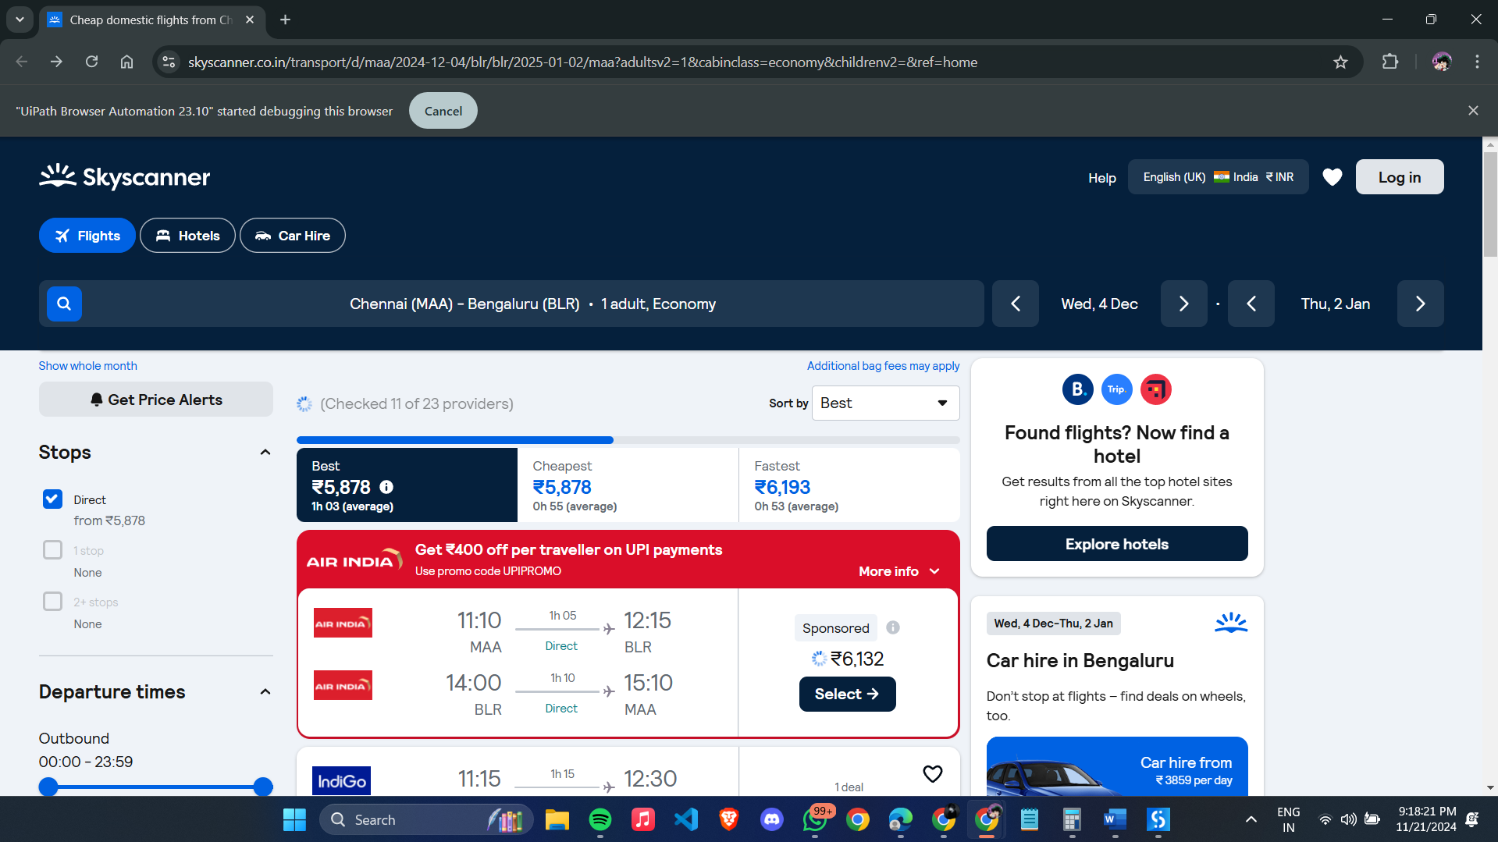

Fig 5.1 – Input Dialog

The bot get the parent directory and user selects the source and destination as

shown in Fig 5.1.

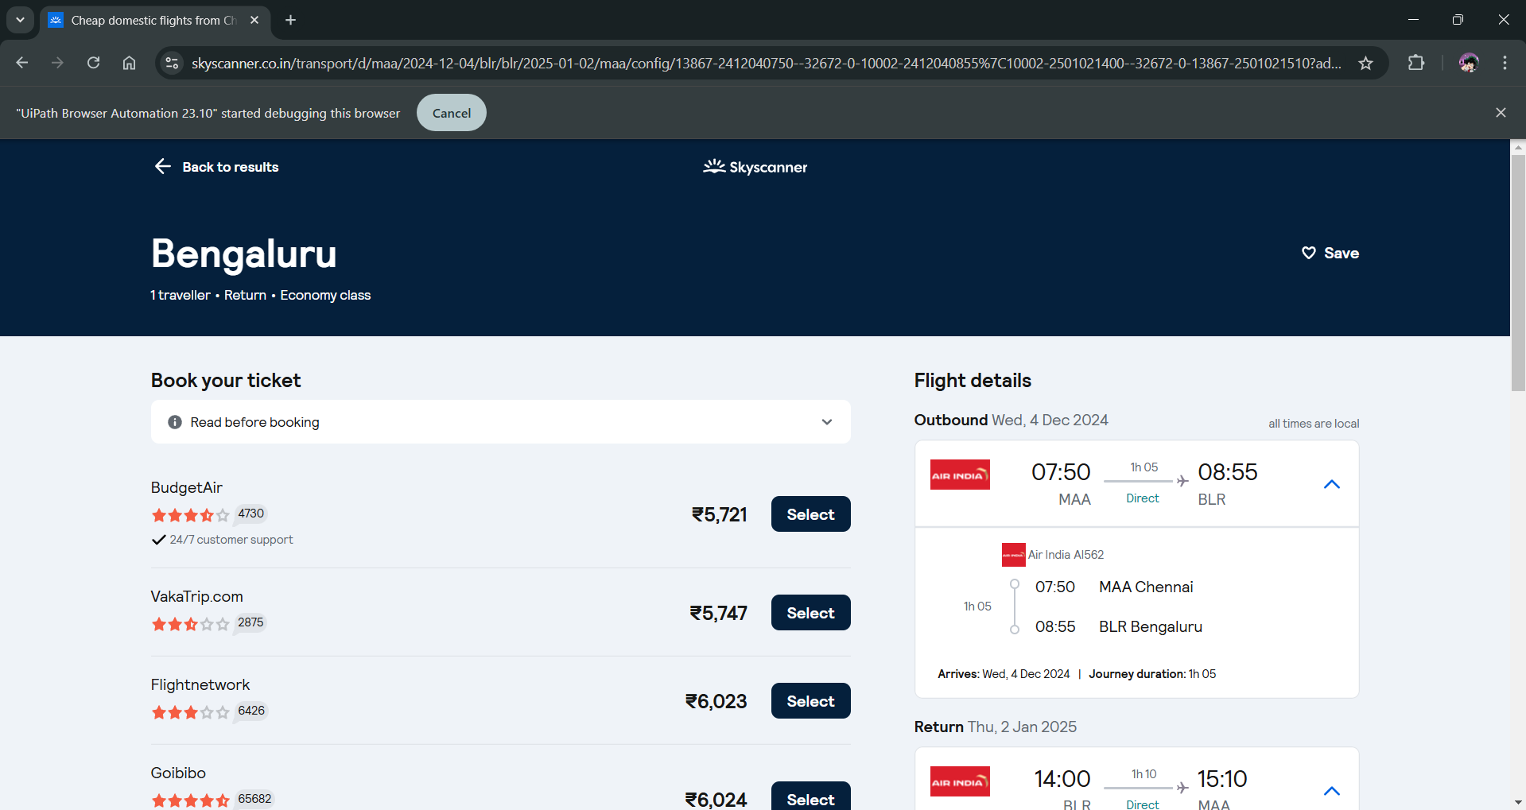

Fig 5.2 – Excel File Creation

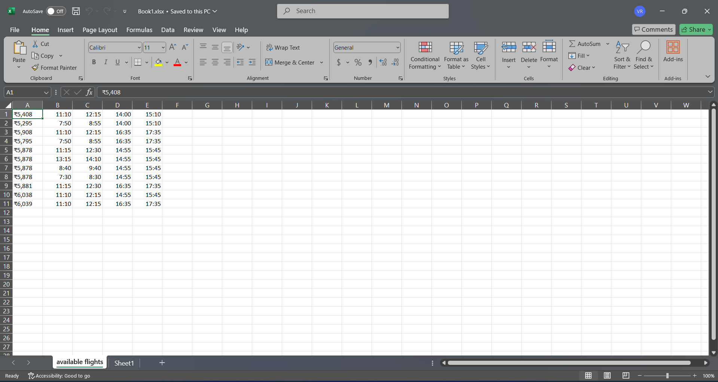The bot creates an excel file report in the main directory for the selected folder as shown

Fig 5.3 – Excel Report

The results are then updated to the excel file that was created at the early steps of execution and saved as it is shown in Fig 5.5.

# CHAPTER 6 CONCLUSION

The automation workflow developed using UiPath significantly enhances the efficiency, accuracy, and consistency of repetitive tasks such as data extraction, processing, and report generation. By eliminating manual intervention, the workflow streamlines business processes, saving valuable time and reducing human error. It automates the entire process, from data collection to output generation, ensuring a smooth and reliable execution that improves overall productivity.

This solution is highly adaptable, offering scalability and customization to meet the specific needs of various industries and use cases. The integration with Excel workbooks and seamless orchestration of tasks ensures that the workflow can handle a wide range of data processing scenarios effectively.

Ultimately, this project exemplifies the transformative potential of Robotic Process Automation (RPA) in optimizing business operations. By automating routine tasks, it enables organizations to focus on more strategic activities, fostering innovation and improving operational efficiency. This automation framework stands as a step forward in enhancing productivity, consistency, and accuracy within workflows, making it a valuable asset for modern businesses.

# APPENDIX PROCESS WORK FLOW

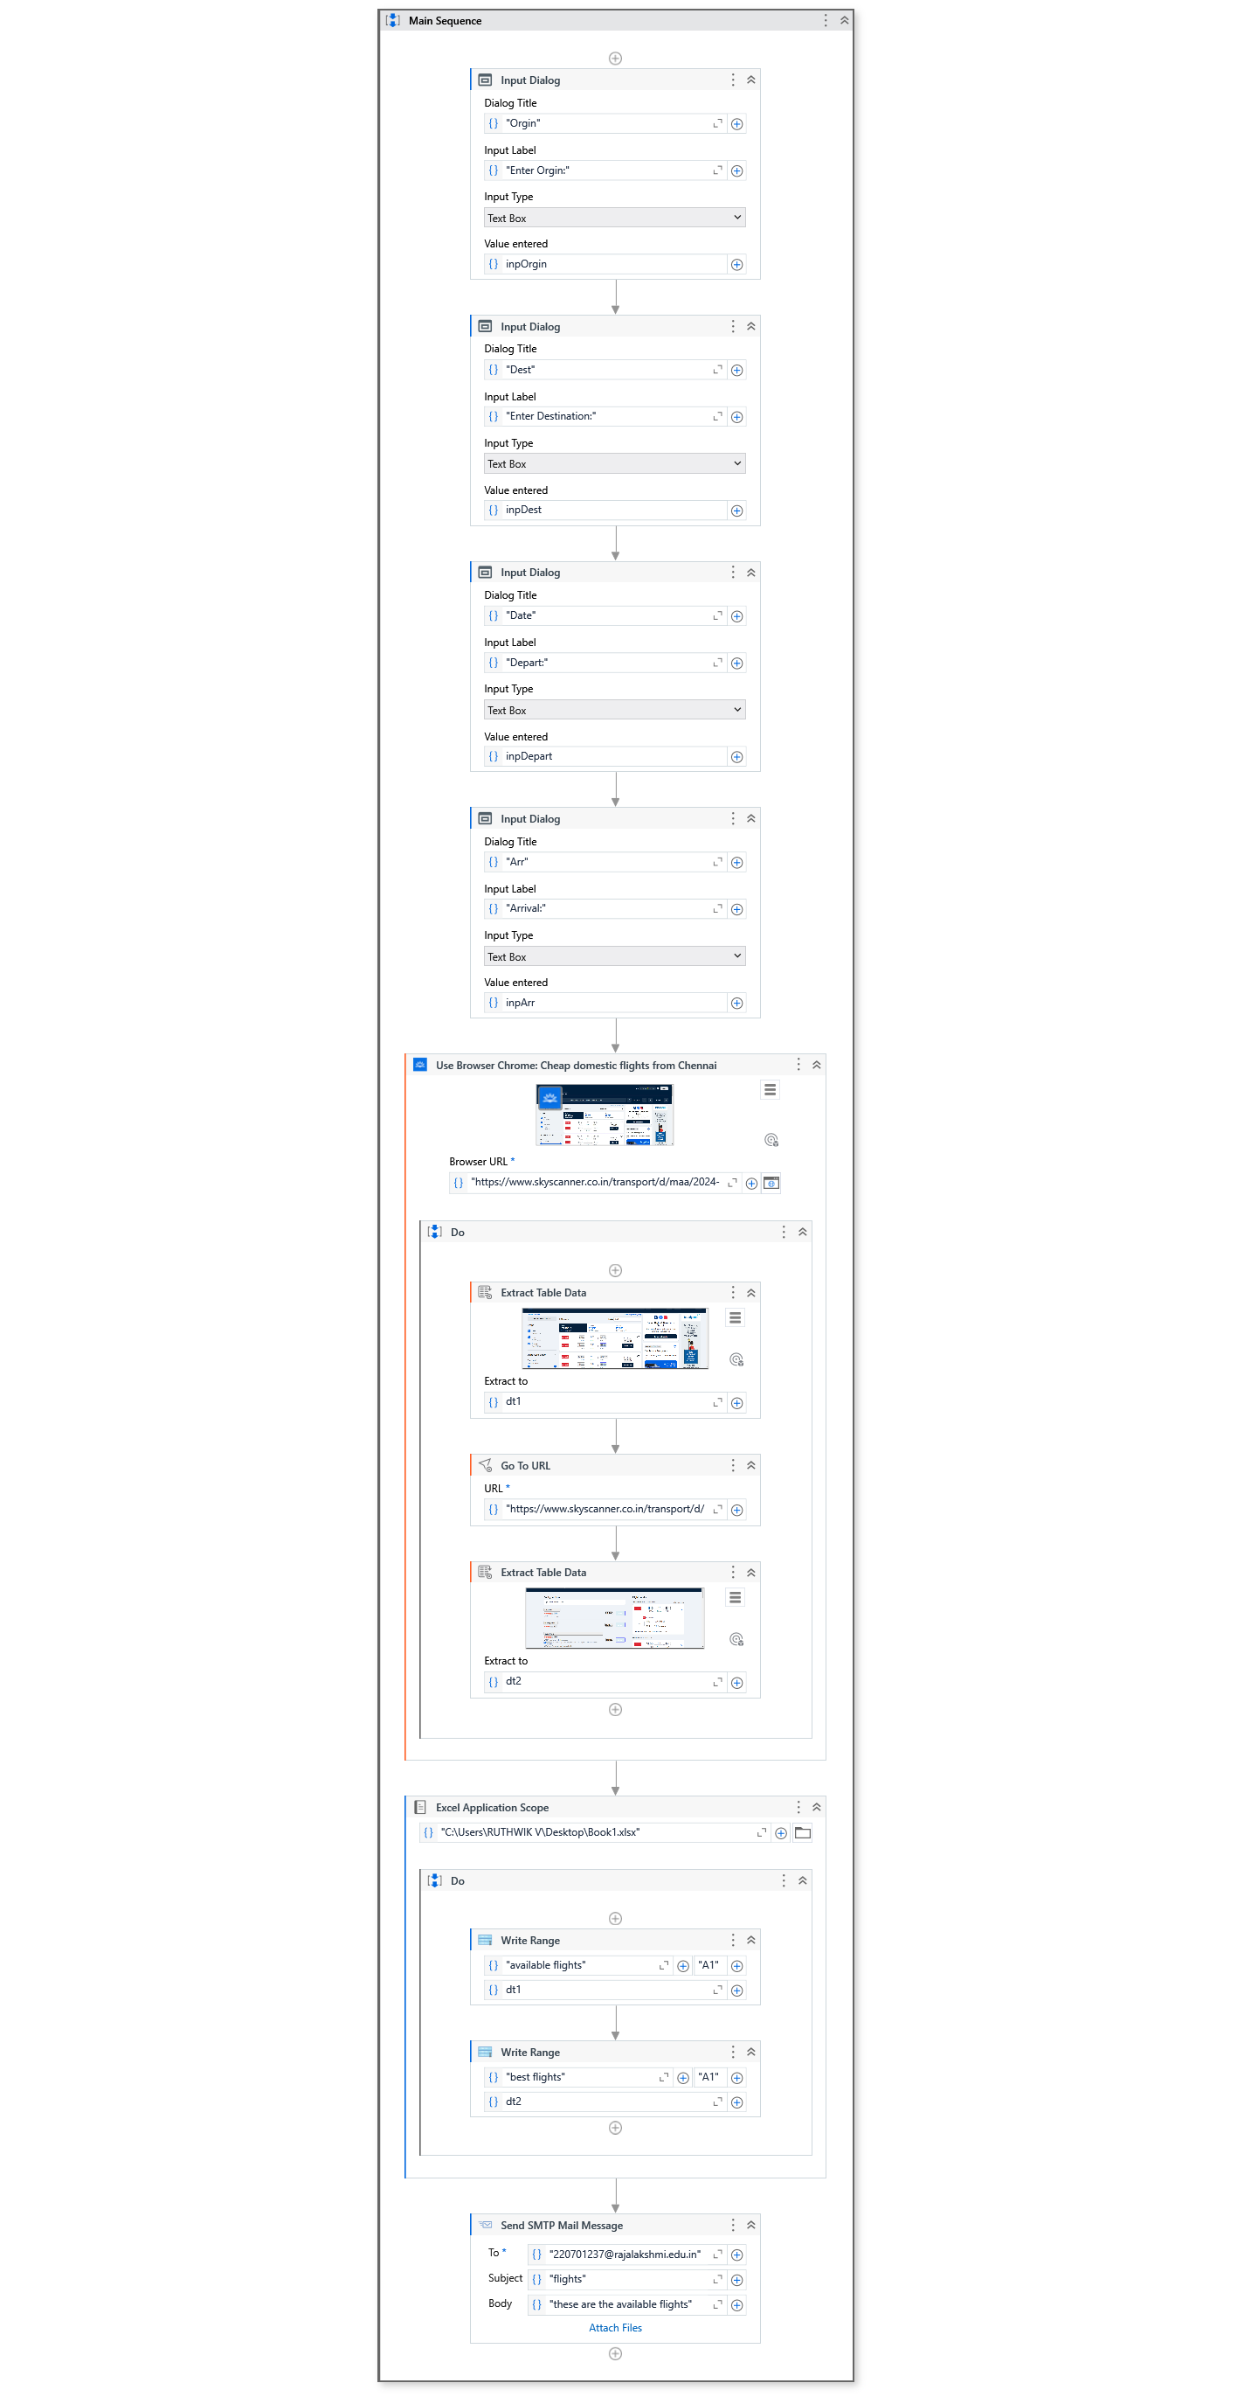

# REFERENCES

1. Kuppusamy, Palanivel & Joseph K, Suresh. (2020). [Robotic Process](https://ijcrt.org/papers/IJCRT2006516.pdf) [Automation to Smart Education](https://ijcrt.org/papers/IJCRT2006516.pdf). 3775.
2. Patil, Dr & Mane, Vinod & Patil, Dr. (2019). [Social Innovation in](https://www.ijitee.org/wp-content/uploads/papers/v8i11/K21480981119.pdf) [Education System by using Robotic Proces](https://www.ijitee.org/wp-content/uploads/papers/v8i11/K21480981119.pdf)s Automation (Rpa). International Journal of Innovative Technology and Exploring Engineering. 8. 3757-3760. 10.35940/ijitee.K2148.0981119.
3. Elkhatat, A.M., Elsaid, K. & Almeer, S. [Evaluating the efficacy of](https://edintegrity.biomedcentral.com/articles/10.1007/s40979-023-00140-5) [AI content detection tools in differentiating between human and AI-](https://edintegrity.biomedcentral.com/articles/10.1007/s40979-023-00140-5) [generated text](https://edintegrity.biomedcentral.com/articles/10.1007/s40979-023-00140-5). *Int J Educ Integr* **19**, 17 (2023). <https://doi.org/10.1007/s40979-023-00140-5>

[4] H. Alamleh, A. A. S. AlQahtani and A. ElSaid, "[Distinguishing](https://ieeexplore.ieee.org/document/10137767/) [Human-Written and ChatGPT-Generated Text Using Machine](https://ieeexplore.ieee.org/document/10137767/) Learning," 2023 Systems and Information Engineering Design Symposium (SIEDS), Charlottesville, VA, USA, 2023, pp. 154-158, doi: 10.1109/SIEDS58326.2023.10137767.

[5] Tomáš Foltýnek, Norman Meuschke, and Bela Gipp. 2019. [Academic Plagiarism Detection: A Systematic Literature Review](https://dl.acm.org/doi/fullHtml/10.1145/3345317). ACM Comput. Surv. 52, 6, Article 112 (November 2020), 42 pages. <https://doi.org/10.1145/3345317>

[6] H. A. Chowdhury, D. K. Bhattacharyya, “[Plagiarism: Taxonomy,](https://arxiv.org/pdf/1801.06323.pdf) [Tools and Detection Techniques](https://arxiv.org/pdf/1801.06323.pdf)”, 19th National Convention on Knowledge, Library and Information Networking, 2018.